Persona Documentations: 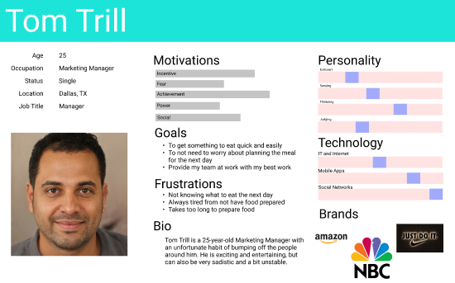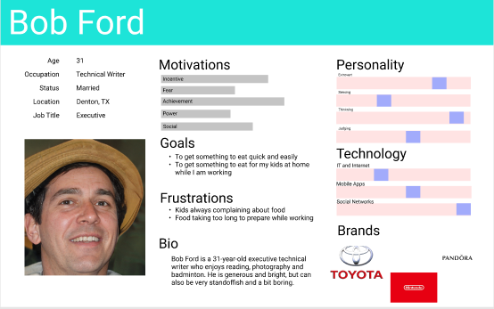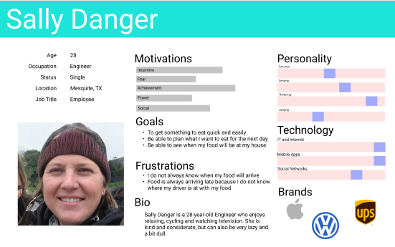

Name of the app: Fresh to You Eats

MVP:

1. The app should be able to keep track of where the delivery driver is at.
2. The app should show the status of when the food will be ready.
3. The app should be able to recommend places that you like to eat.
4. The app should show the closest restaurants that are available to deliver.
5. The app should allow the restaurants to opt-in or out of the program.
6. The app should allow the restaurants to show what food is available on that day.

User Stories:

1. As a user, I want to know where my food is at as it is being delivered to me.
2. As a user, I want to know the progress of how far along my food is being prepared.
3. As a user, I want to know what places there are based on what I feel like eating.
4. As a user, I want to know what restaurants are available to deliver to me.
5. As a restaurant owner, I want to be able to let the customer know if we can deliver to them.
6. As a restaurant owner, I want to be able to show the specific food items that are available on that day.

Trello Board:

<https://trello.com/b/yUGzWwt6>

Figma Wire frames/Homepage:

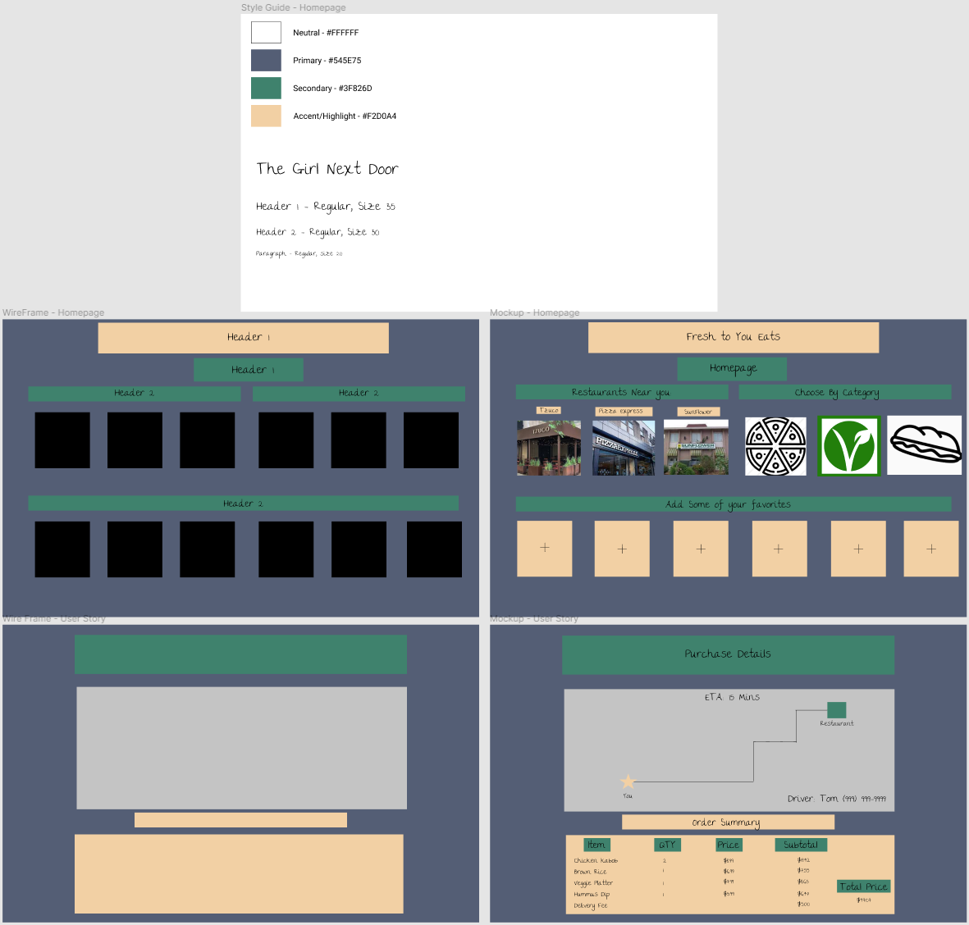https://www.figma.com/file/k5pMI6MyVqn0IwcJ65v0Ms/Untitled?node-id=0%3A1